He’s a Heretic:

RebukeFrancis.com/Mcelroy.pdf

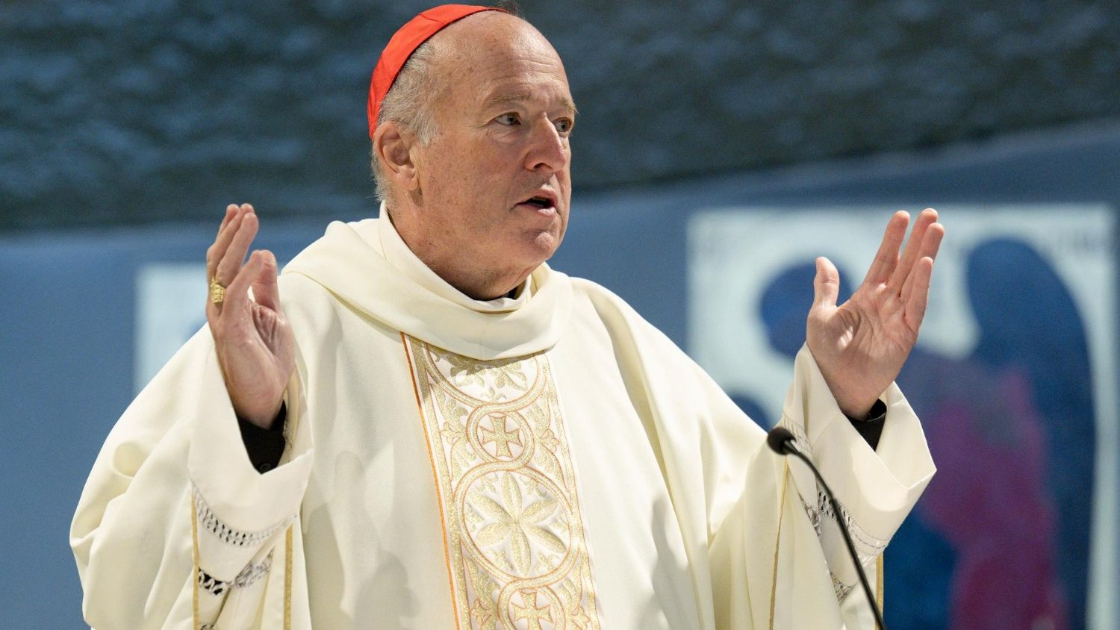

He’s a Heretic:

RebukeFrancis.com/Mcelroy.pdf



He’s a Heretic:

RebukeFrancis.com/Mcelroy.pdf



He’s a Heretic:

RebukeFrancis.com/Mcelroy.pdf



He’s a Heretic:

RebukeFrancis.com/Mcelroy.pdf



He’s a Heretic:

RebukeFrancis.com/Mcelroy.pdf



He’s a Heretic:

RebukeFrancis.com/Mcelroy.pdf



He’s a Heretic:

RebukeFrancis.com/Mcelroy.pdf



He’s a Heretic:

RebukeFrancis.com/Mcelroy.pdf



He’s a Heretic:

RebukeFrancis.com/Mcelroy.pdf



He’s a Heretic:

RebukeFrancis.com/Mcelroy.pdf



He’s a Heretic:

RebukeFrancis.com/Mcelroy.pdf

